Disabling Application Security Prompts
Last Updated: Jul 03, 2013 09:24AM NZST
Disabling the “Do you want to allow this website to open a program on your computer?” prompt
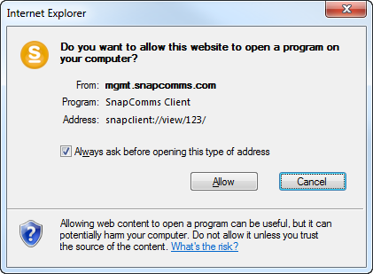
This prompt can be disabled by the following registry edit:
HKCU: to affect current user only:
[HKEY_CURRENT_USER\Software\Microsoft\Internet Explorer\ProtocolExecute\snapclient]
"WarnOnOpen"=dword:00000000

HKLM: to affect local machine – for 32 bit machines
[HKEY_LOCAL_MACHINE\SOFTWARE\Microsoft\Internet Explorer\ProtocolExecute\snapclient]
"WarnOnOpen"=dword:00000000

HKLM: to affect entire machine – for 64-bit machines
[HKEY_LOCAL_MACHINE\SOFTWARE\Wow6432Node\Microsoft\Internet Explorer\ProtocolExecute\snapclient]
"WarnOnOpen"=dword:00000000

Disabling the “A website wants to open web content using this program on your computer” prompt
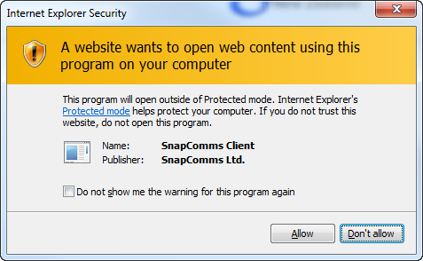
This prompt can be disabled by the following registry edit:

HKCU: to affect current user only:
[HKEY_CURRENT_USER\Software\Microsoft\Internet Explorer\Low Rights\ElevationPolicy\{C30D9E87-2858-4F56-AF3A-A51692B812B2}]
"AppPath"="C:\\Program Files\\SnapComms\\Client\\402"
"AppName"="SnapClient.exe"
"Policy"=dword:00000003

HKLM: to affect local machine – for 32 bit machines
[HKEY_LOCAL_MACHINE\Software\Microsoft\Internet Explorer\Low Rights\ElevationPolicy\{C30D9E87-2858-4F56-AF3A-A51692B812B2}]
"AppPath"="C:\\Program Files\\SnapComms\\Client\\402"
"AppName"="SnapClient.exe"
"Policy"=dword:00000003

HKLM: to affect entire machine – for 64-bit machines
[HKEY_LOCAL_MACHINE\Software\Wow6432Node\Microsoft\Internet Explorer\Low Rights\ElevationPolicy\{C30D9E87-2858-4F56-AF3A-A51692B812B2}]
"AppPath"="C:\\Program Files (x86)\\SnapComms\\Client\\402"
"AppName"="SnapClient.exe"
"Policy"=dword:00000003

Please note the above registry keys need to specify the exact paths to the directory where the SnapClient.exe is located (highlighted in yellow above).
On 32-bit Windows this is by default under the: C:\Program Files\ directory
On 64-bit Windows this is by default under the: C:\Program Files (x86)\ directory

Zipped .REG files of all the above are attached to this article below.

